DESIGNING OF 3PHASE VOLTAGE
SOURCE FROM DC SUPPLY

A MINI PROJECT

REPORT

Submitted by

ANUBHAB KUMAR DAS

ABDUL KARIM MIDDYA

SOUVIK DAS

JAGANNATH BHABAK

PRIYANKA BHOWMIK

OF

B.TECH

IN

APPLIED ELECTRONICS AND INSTRUMENTATION(AEIE),

3rd Year, 6th Semester

Department of Applied Electronics & Instrumentation Engineering
Heritage Institute of Technology

AUGUST 2021

HERITAGE INSTITUTE OF TECHNOLOGY

BONAFIDE CERTIFICATE

Certified that this project report “DESIGNING OF 3PHASE VOLTAGE SOURCE FROM DC SUPPLY” is the bonafide work of “ANUBHAB KUMAR DAS, ABDUL KARIM MIDDYA, SOUVIK DAS, JAGANNATH BHABAK, PRIYANKA BHOWMIK” who carried out the mini project work under our
supervision.

<<Signature of the Supervisor with date>>

<<Name of the Supervisors>>

<<Academic Designation of Supervisor>>

Submitted to the Viva voce Examination held on _____________________

TABLE OF CONTENTS

SL.NO | Contents | Page Number
1 | INTRODUCTION | 4
2 | SOFTWARE USED | 4
3 | COMPONENTS USED | 5
4 | Circuit diagram | 5
5 | Working principle | 5
6 | CALCULATION | 6
7 | ARDUINO PROGRAM | 6
8 | RESULT | 8
9 | REFERENCES | 8

INTRODUCTION

Three-phase systems are used to distribute high power to buildings and are suitable for driving powerful electric motor equipment. The wiring is designed so that the power drawn from each phase is equal. This is accomplished by connecting all high-power loads to all three phases and distributing all of the smaller loads having three phases.
Three-phase power has three live wires, 120° out of phase with each other. The color code of three wires are YELLOW, RED and BLUE.
Two types of connections are possible in 3 phase, namely delta (Δ) connection and star (Y) connection. The load and the source can be either be in delta or star.
Three phase converter converts DC supply to 3 phase AC supply.

SOFTWARE USED: Here we have designed this circuit using Proteus Design Suite. The Proteus Design Suite is a proprietary software tool suite used primarily for electronic design automation. The software is used mainly by electronic design engineers and technicians to create schematics and electronic prints for manufacturing printed circuit boards.

COMPONENTS USED:

Sl no. | Name | Quantity | Specification
1 | Arduino-Uno Board | 1 | 16 MHZ, ATMEGA328p Micro controller
2 | Resistor (Load) | 3 | 1KΩ, 1/2 watt,
3 | SCR | 6 | - S6010R, Voltage capability up to 1000 V
4 | Diode | 6 | 1N4007
5 | Capacitor | 1 | 10uF,200V, non-electrolytic
6 | Battery | 1 | 5V, 0.1Ω

PROJECT DESIGN:

- Circuit diagram:

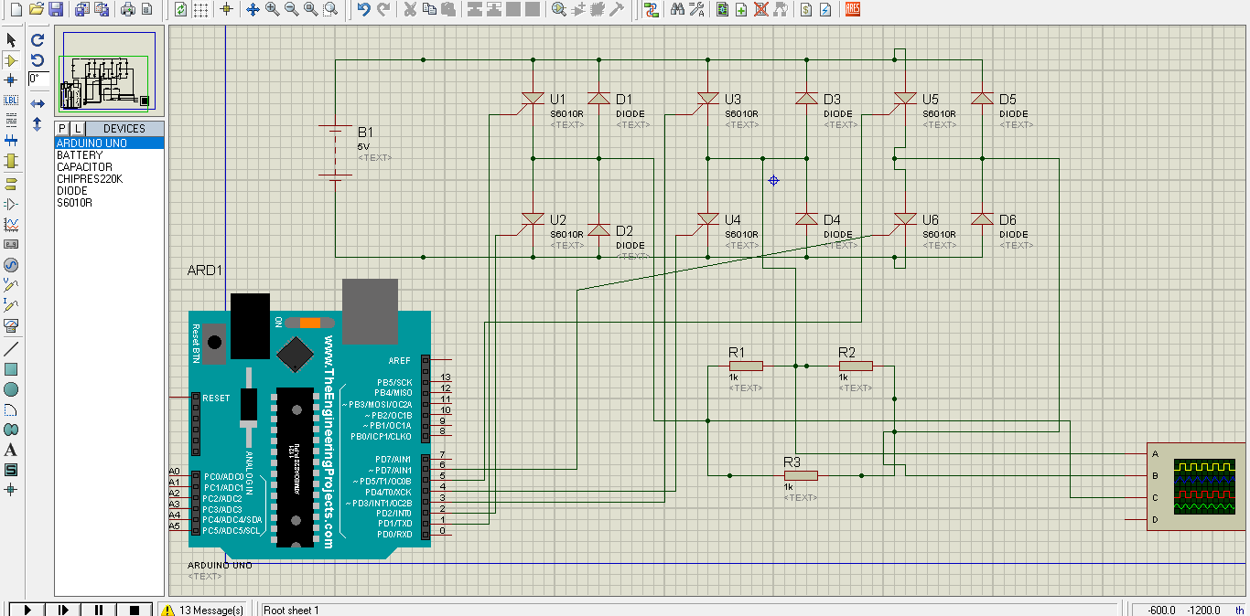
(fig.i)

- Working principle and circuit description: 5V dc voltage is applied at input. Six SCRs and diodes are connected with their opposite polarity as shown in the figure(Fig.i). After every 60° phase shift we have to ON a particular pair of SCR to generate 3 phase waveform having phase shift of 120°. each. We made to trigger the pair of SCR, (1,4), (1,6), (3,6), (2,3), (2,5), (5,4), (1,4) after every 60° iteration. For triggering those SCR we have designed a trigger circuit using Arduino-UNO. We have connected the gate terminals of SCR to the digital pin 1-6 to get trigger to the SCRs for conduction. The freewheeling diodes are connected across the SCR as shown in the figure to avoid the reverse current produced by the coil incase of 3phase induction motor. Here we have connected a delta (Δ) load across the output.

- Calculation: To generate 50Hz signal we have to trigger those SCR pair after some estimated time. The time will be,
T = ((1/50))/6 sec = 3.33mSec.

- Arduino program:

int a = 1,b=2,c=3,d=4,e=5,f=6;

void setup() {
pinMode(a,OUTPUT);
pinMode(b,OUTPUT);
pinMode(c,OUTPUT);
pinMode(d,OUTPUT);
pinMode(e,OUTPUT);
pinMode(f,OUTPUT);
}

void loop() {
digitalWrite(a,HIGH);
digitalWrite(d,HIGH);
digitalWrite(b,LOW);
digitalWrite(c,LOW);
digitalWrite(e,LOW);
digitalWrite(f,LOW);

delay(3.33);

digitalWrite(a,HIGH);
digitalWrite(f,HIGH);
digitalWrite(b,LOW);
digitalWrite(c,LOW);
digitalWrite(d,LOW);
digitalWrite(e,LOW);
delay(3.33);

digitalWrite(c,HIGH);
digitalWrite(f,HIGH);
digitalWrite(a,LOW);
digitalWrite(b,LOW);
digitalWrite(d,LOW);
digitalWrite(e,LOW);
delay(3.33);

digitalWrite(2,HIGH);
digitalWrite(3,HIGH);
digitalWrite(1,LOW);
digitalWrite(4,LOW);
digitalWrite(5,LOW);
digitalWrite(6,LOW);
delay(3.33);

digitalWrite(2,HIGH);
digitalWrite(5,HIGH);
digitalWrite(1,LOW);
digitalWrite(3,LOW);
digitalWrite(4,LOW);
digitalWrite(6,LOW);
delay(3.33);

digitalWrite(5,HIGH);
digitalWrite(4,HIGH);
digitalWrite(1,LOW);
digitalWrite(2,LOW);
digitalWrite(3,LOW);
digitalWrite(6,LOW);
delay(3.33);

digitalWrite(1,HIGH);
digitalWrite(4,HIGH);
digitalWrite(2,LOW);
digitalWrite(3,LOW);
digitalWrite(5,LOW);
digitalWrite(6,LOW);
delay(3.33);

}

RESULTS & DISCUSSION: we got 3 phase square waveform having frequency of 50Hz(approx.) from oscilloscope as shown below (Fig.2).

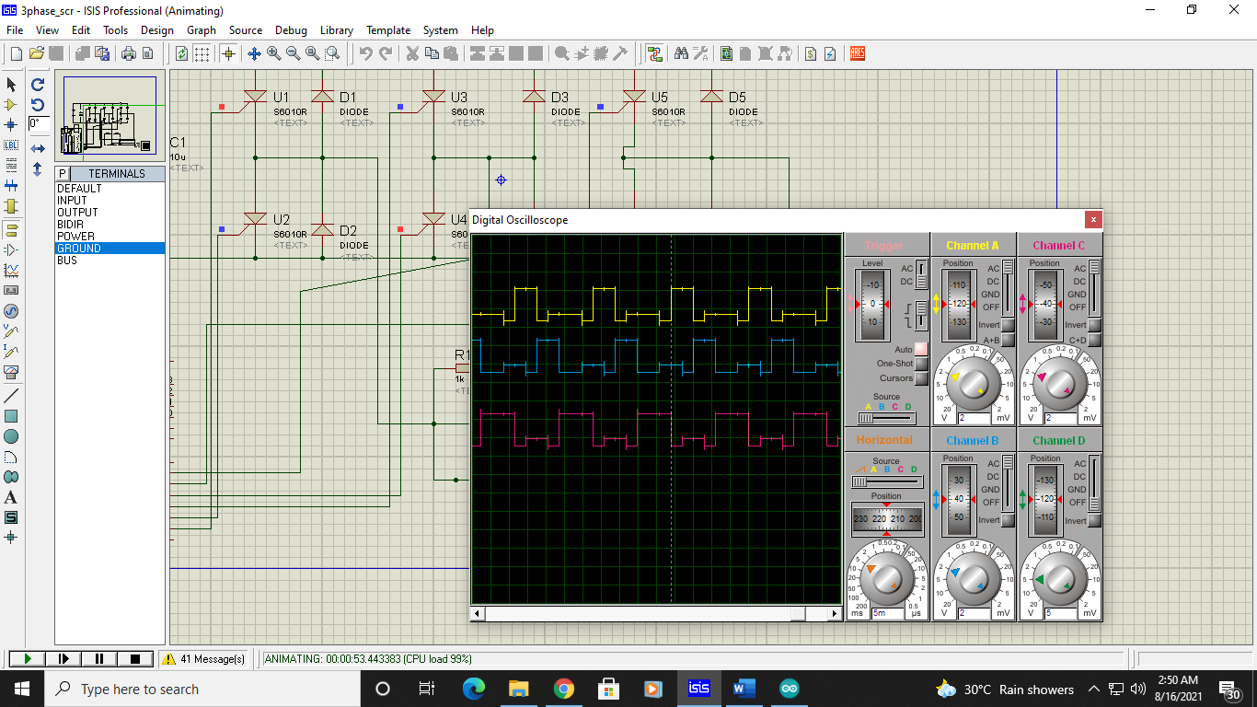
Fig.2

CONCLUSION:
It was a knowledgeable and learning experience for us while working on this project. This project took us through various phases of project development and gave us more knowledge about 3 phase voltage source. We can learn to use a new software like ‘PROTEUS’ and build a project on the software by using various components. The purpose of this project is to improve our practical knowledge so that we will develop the project to constitute a big project for future use.

REFERENCES: We got help from those sites,

https://en.wikipedia.org/wiki/Three-phase_electric_power

https://www.youtube.com/watch?v=cNlmjtcr8D4

https://www.electronics-tutorial.net/dc-to-ac-inverter/three-phase-inverter/



